
CYB 110-T02 Security With Linux
MODULE 7: CHAPTER 7: EXERCISE N/A

March 22, 2026

Professor: Nathan Rackley
Student: Jamison Durham

Table of Contents
Metasploitable 2 Install 2
Assignment: 2
Assignment Response: 2
References 6

Metasploitable 2 Install

Assignment:
- Show several screenshots proving you have Metasploitable successfully installed in Virtualbox/VMware.
- You do not need to show the installation process, only the result.
- Show a running Metasploitable.
- Log in with msfadmin:msfadmin. Use the echo command to display your name.
- Show the results of a basic nmap scan of the Metasploitable IP address from Kali Linux. Use your-name-account in the command line (e.g. joe@kali).
- Upload the report here in Canvas.
- Follow the 'Assignment & Paper Template Requirements

Assignment Response:

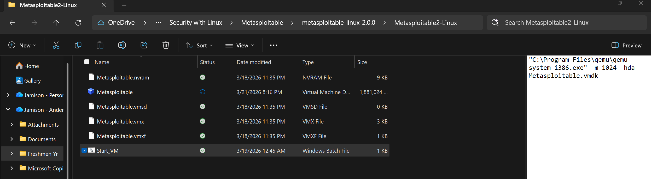
Since my laptop runs a new Snapdragon ARM processor, there was an alternate route that I had to take to download Metasploitable 2. Through a third-party emulator (translator) I was able to download Metasploitable 2 by running code through the Microsoft command prompt. Here you can see a saved note in the Microsoft files in File Explorer. This note has the code that runs the QEMU emulator. Once I click the saved note of code, Metasploitable 2 is able to run.

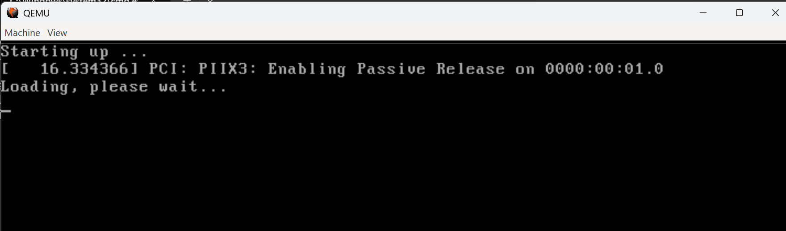
Metasploitable 2 is not running through a virtual machine like VirtualBox but rather runs through Microsoft command prompt.
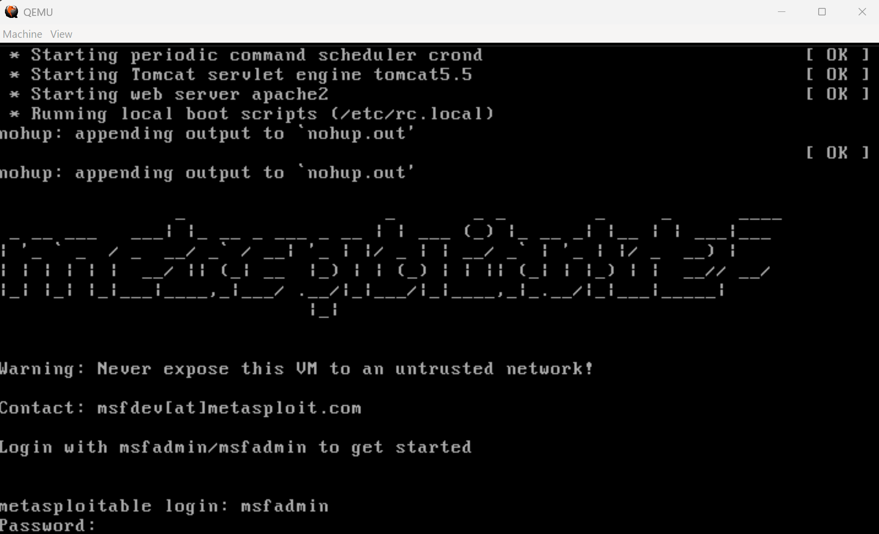
Metasploitable 2 is running. I was able to sign in as the msfadmin user.

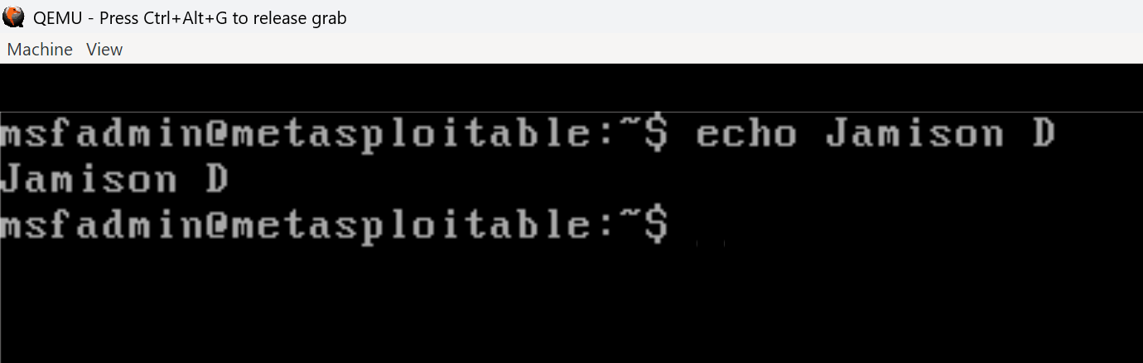
I was able to use the echo command to echo my name.

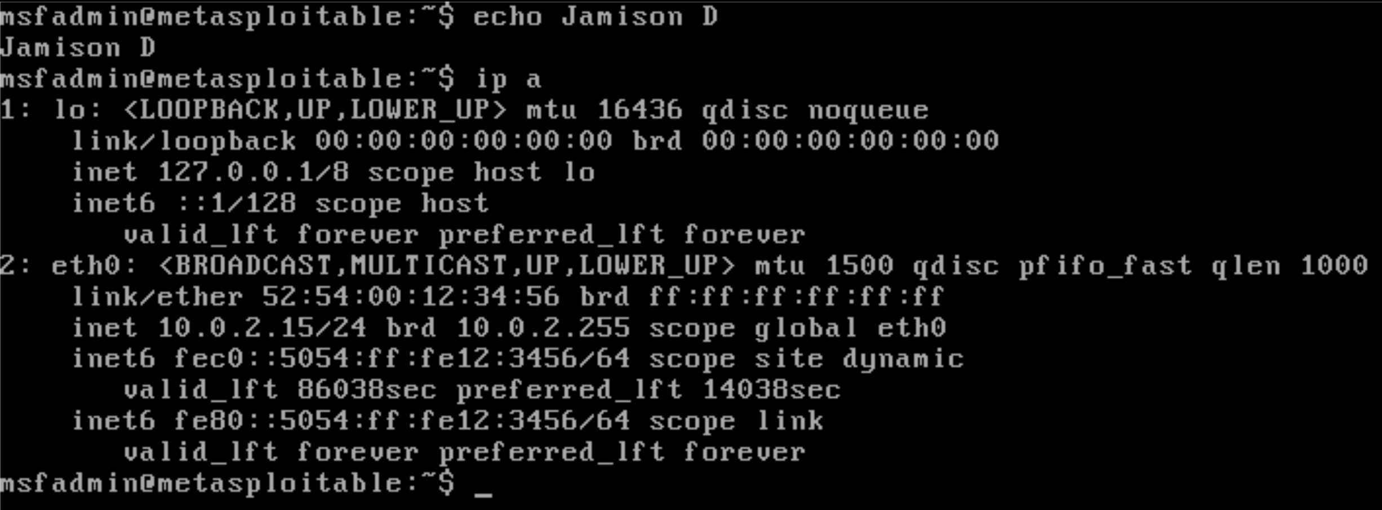
The ip a shows the NIC connection. The ip address is revealed here as well.

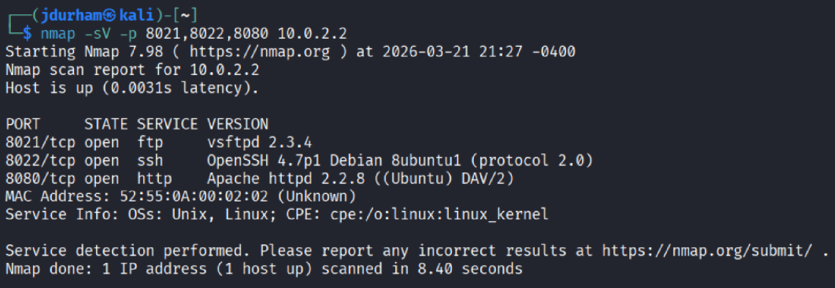
Through immense troubleshooting, I was able to scan the ports that were open. Since my Metasploitable was running through Microsoft and not through Virtual Box like the Kali machine, I had to find the open ports online to scan for validity. They are using the same subnet and they are on the same network, although they are on different virtual routers. This is why the screenshot above shows 10.0.2.2 (my laptop) instead of 10.0.2.15 (Metasploitable).

Sorry for the confusion with this assignment. Having the ARM processor forced me to study in depth what was happening in this exercise!

References
- https://www.youtube.com/watch?v=g1JnLIfTjzM
- https://www.qemu.org/docs/master/
- https://www.virtualbox.org/manual/ch06.html

